请包含如下内容：
All KPS including
Sales Ach rate% （by store） ， Time process,
New Product Analysis (with Picture) – will provide later （这个也要教会我）

Transaction w/ HJ = Transaction
AVB w/o HJ = AVB core
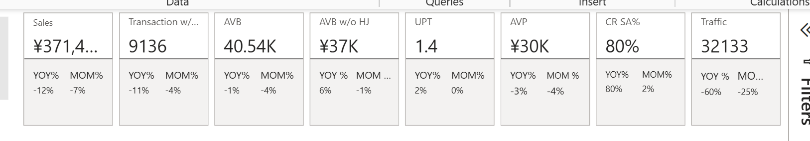
Sales by different dimensions.
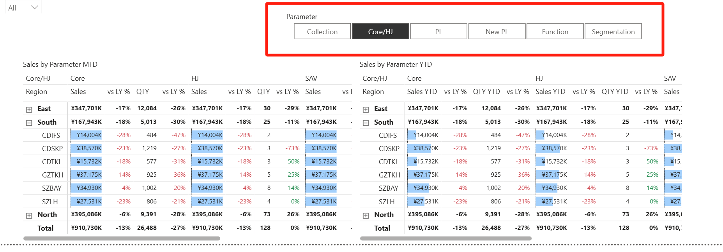
Sales Trend by Week, by Month
Traffic Trends
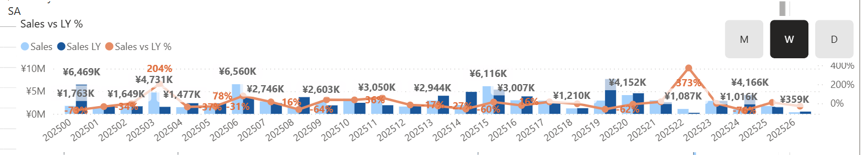
各项KIP，Region – South + LFL store

